**Mood Scriber: Data Challenge ‘24**

**Sample dataset – Input.xlsx.**

Initially, the excel file consisted of four key columns- ***Day****,* ***Mood****,* ***Activity-1*** *and* ***Activity-2.*** By incorporating additional columns (***Sleep Quality****,* ***Productivity Score****,* ***Energy Level*** *and* ***Notes/Comments***), we can gather more comprehensive insights from the data.

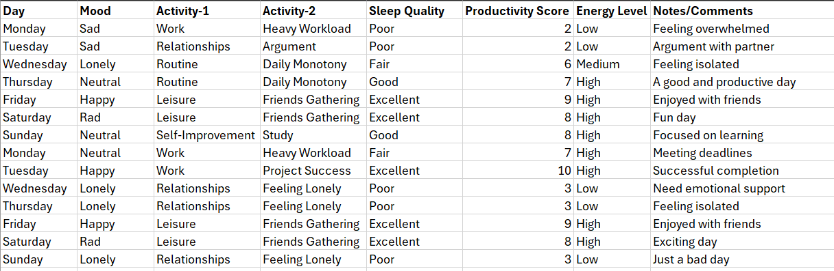

From the provided data, we can extract several insights about the person's mood, activities, sleep quality, productivity score, and energy level over the course of multiple days.

**Mood Patterns:**

The person went through many different feelings during the week, like **Sad, Lonely, Neutral, Happy, Rad, Angry, Routine, Awful and Depressed**. Some emotions appeared more often on certain days. For instance, feeling **Lonely** was common on **Wednesday** and **Thursday**. What's interesting is that the person mostly felt **Neutral** and **Happy**, and rarely felt **Awful** and **Depressed**. This suggests that the person generally had a good week emotionally, with more positive feelings than negative ones.

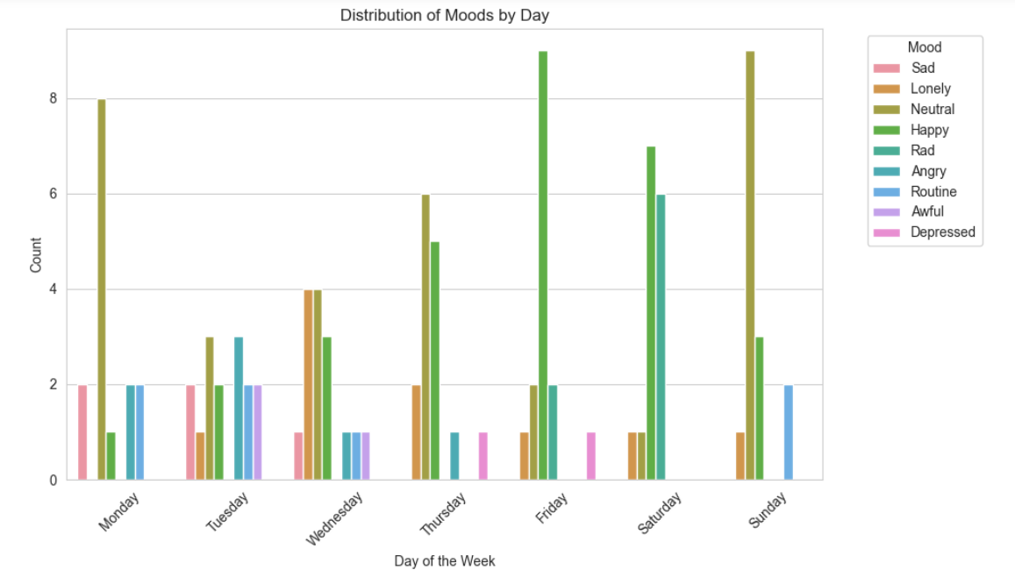

**Distribution of activities:**

When we looked at the distribution of Activity 1, we noticed that the person did a lot of **Work** and spent time on **Relationships** and **Leisure** more as compared to other activities. On the other hand, activities related to **Health** and **Finance** were the least common. We also found that activities like **work**, **relationships** and **routine** were more common on weekdays, while activities like **self-improvement** and **leisure** were more common on weekends.

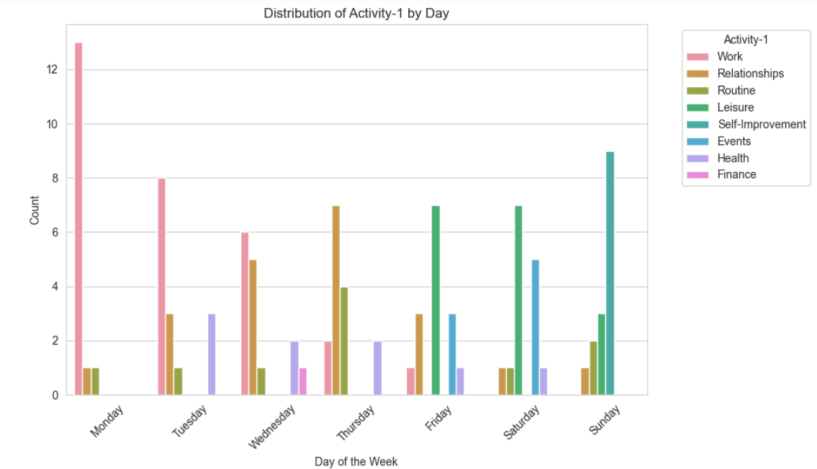

When we analysed the distribution of Activity 2, we found that the most common activity was **daily monotony**, followed by **relaxing** and a **busy schedule**.

Also, we found that **Mondays** stood out as the busiest days, with the highest frequency of **busy schedules**. Sundays, on the other hand, were primarily spent **studying**. Additionally, activities like **doctor visits, financial goals, job promotions, fitness goals, and dealing with demise** occurred the least frequently, with a frequency of 1.

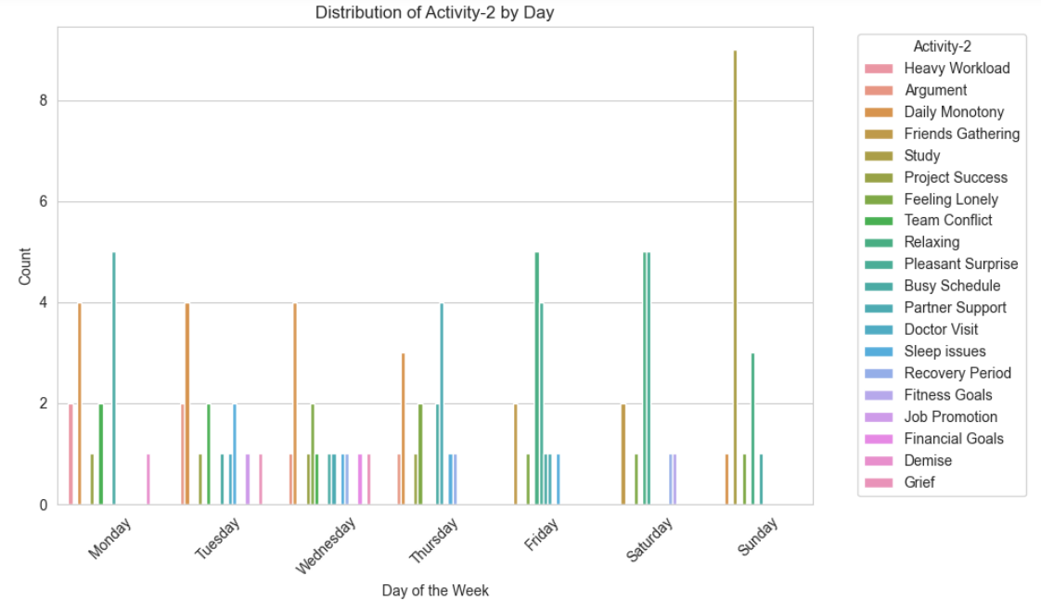

**Activity and Mood Correlation:**

This heatmap reveals that the person maintains a **neutral** mood while engaging **in work-related**, **self-improvement** and **routine** tasks. The **leisure** activity is primarily associated with positive emotions, with **Happy** being the most frequent mood occurrence. Activities related to **relationships** elicit a mix of emotional responses, including both positive (**Happy**) and negative (**Lonely**, **Sad**) moods.

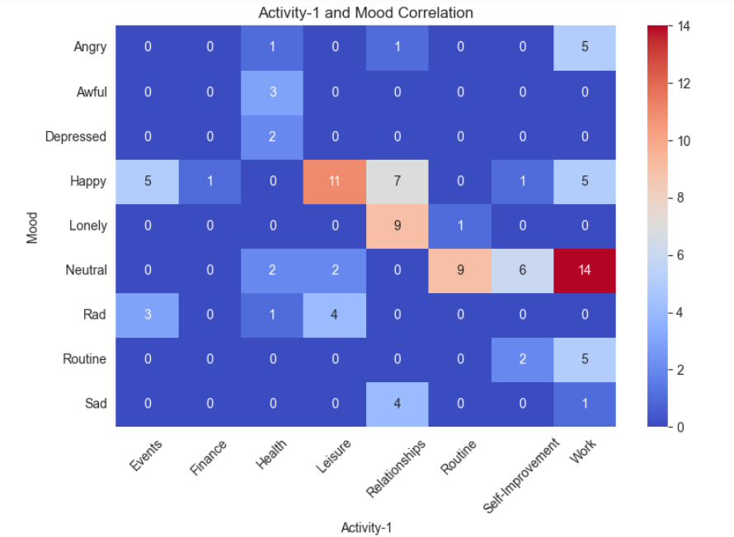

For Activity-2, **Neutral** is the most common mood for both **'busy schedule**' and **'daily monotony**' activities. Certain activities seem to be associated with particular mood states. For instance, feeling **Sad** is linked with **Heavy Workload** and **Angry** is due to the **Team Conflict**, while feeling **Happy** or **Rad** is associated with social activities like **Friends Gathering**, **Pleasant surprise** and **Relaxing**.

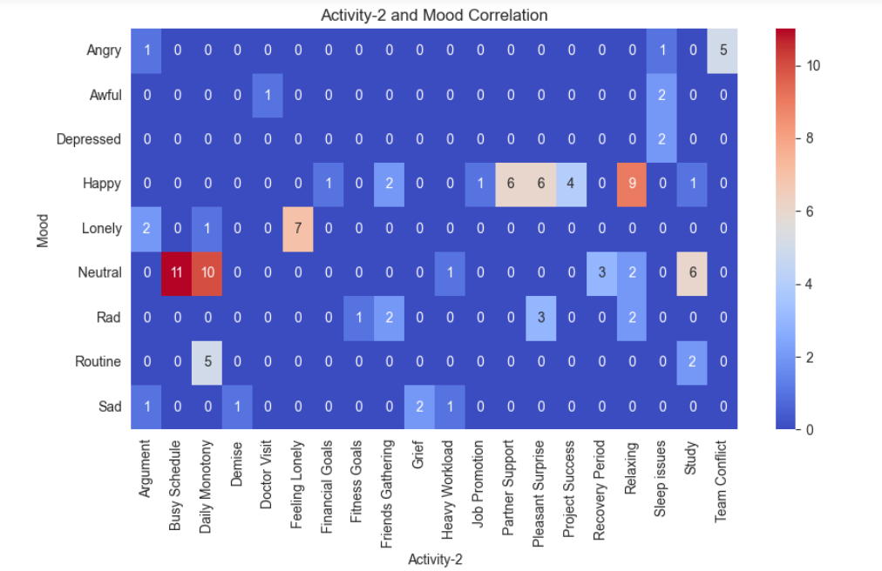

**Sleep Quality and Productivity score:**

We observed that when the person experienced negative emotions such as **depression**, **loneliness**, **anger**, **or sadness**, their sleep quality tended to suffer, leading to lower productivity score. This suggests that emotional distress can significantly impact both sleep patterns and the ability to perform tasks efficiently. Days with higher mood states, such as **Happiness** and **Radness**, tend to align with better sleep quality and higher productivity scores, indicating a positive feedback loop between mood and overall functioning.

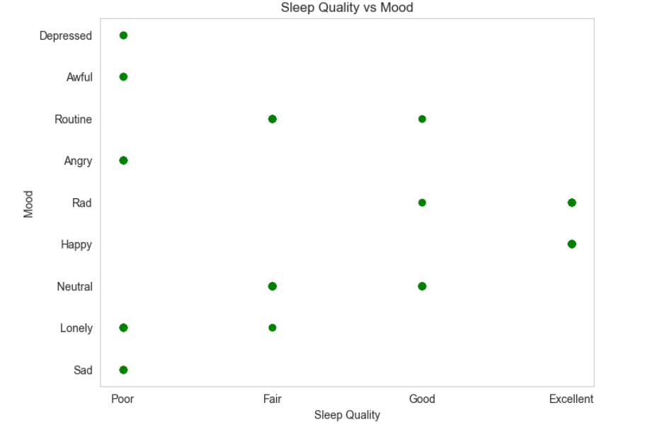 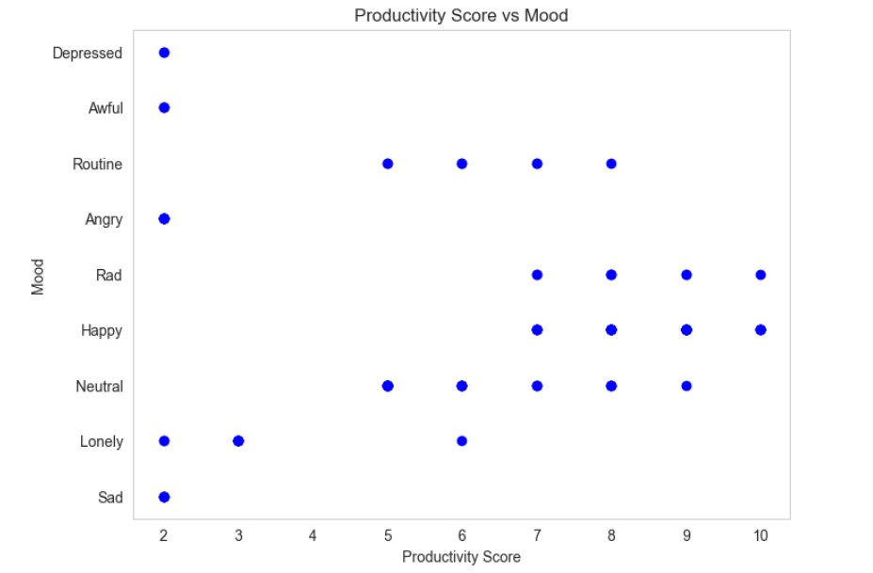

**How energy level affects productivity?**

When energy levels are low, productivity tends to suffer. When the person experiences low energy, they may struggle to focus or engage fully in tasks, leading to decreased productivity. Conversely, higher energy levels (7-10) contribute to enhanced motivation, focus, and efficiency, resulting in heightened productivity levels.

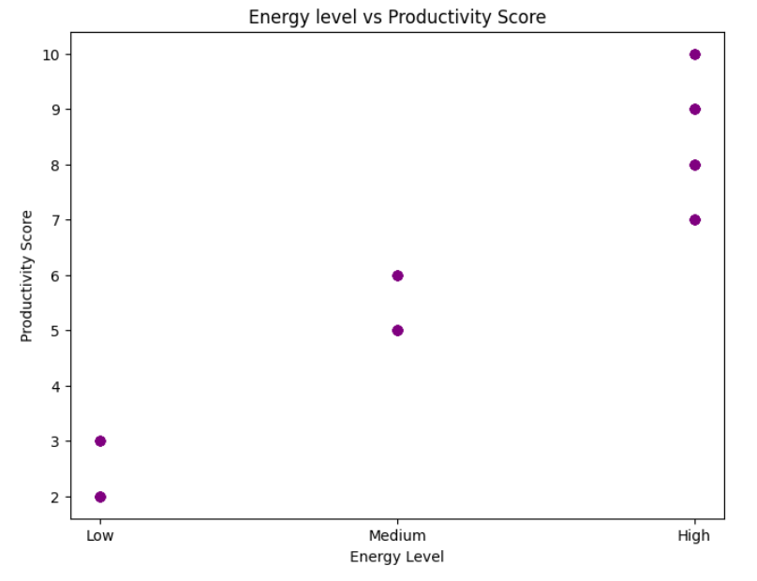

**References:**

Github Repository –

[*https://github.com/akankshasingh200110/MoodScriber-Data-Challenge*](https://github.com/akankshasingh200110/MoodScriber-Data-Challenge)

Google Drive-

[*https://drive.google.com/drive/folders/1CJ9dx1aJRoJfRUP9YLNQSrqGrroooiO5?usp=sharing*](https://drive.google.com/drive/folders/1CJ9dx1aJRoJfRUP9YLNQSrqGrroooiO5?usp=sharing)